- \Operation\Carton\Carton feeding
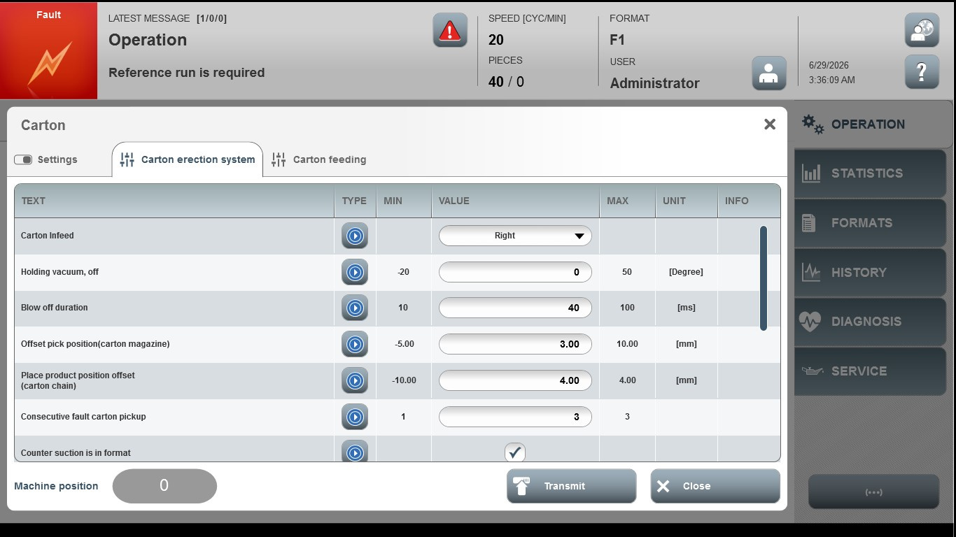
Acceptance criterion | Limits | Pass / Fail: Dev-No. | Date | Initials
Screen matches screenshot | N / A
Vibrator interval | 0 … 10
Vibrator duration | 1.00 … 5.00
Magazine belt overrun | 0 … 5

